# Were the falls in life expectancy in Scotland and other UK countries in 2015 due to chance?

*Authors: add later (HS/NRS)*

## Introduction

### Recent concerns of falling/stalling life expectancy

Life expectancy across all the countries of the UK fell in 2015 with falls of a scale that had not been observed in over half a century [Ref]. Combined with recent concerns of a slowdown in the growth of life expectancy, observed across many other international countries [Ref], the stalling of life expectancy in Scotland and the rest of the UK has become a major public health issue.

### What explanations are being offered?

As the timing and scale of the fall is comparable with other international countries [Ref], there have been suggestions whether the fall and recent underlying trends, were influenced by one or more underlying mechanisms. Several explanations have been proposed, ranging from focusing on the effects of bad winters and influenza [Ref], the effects on health and mortality due to the introduction of austerity policies following the global financial crash of 2008 [Ref], to focusing on the worrying rise in the prevalence of obesity and overweight [Ref]. [Also add in something about mortality displacement/harvesting].

### An alternative way of interpreting the drop

Whilst these explanations seem conceivable [Ref – firm up wording before this reference], they fail to address the position that there was no relationship between the fall in 2015 and the explanations being proposed, and that the observed fall was driven by chance. Likening the 2015 fall in life expectancy to other rare ecological events, for example a 100-year-flood, it is possible that rare outcomes can recur in short time-periods due to chance. For example multiple 100-year-floods can still occur over short time periods and the presence of a 100-year-storm does not always cause a flood event to happen. The risk models used to predict the likelihood of these types of rare events depend entirely on the past, assuming that it is reliable in being able to predict future risk [Ref]. Over the last three decades, Scotland has seen large gains in life expectancy. The counter argument to this is that it indicates a fundamental shift and that the past is a less reliable guide to the future than it used to be. Alternatively this may simply be down to the false sense of security provided by perceptions of average risk in a single time period and how it leads to short- and long-term risk being misunderstood.

### Aim

The aim is to explore the default scenario of how likely it was that the fall in Scottish life expectancy in 2015 was due to chance. The risk of the fall in 2015 in England & Wales will also be assessed to indicate whether it followed a similar pattern. A secondary aim is to introduce the idea that changes in annual life expectancy are related to each other, by focusing on the scenario of whether there were an association between annual fluctuations and what happened in previous years’.

## Methods

### Life Expectancy data

Data pertaining to period life expectancy at birth for the countries of the UK (Scotland, England & Wales and Northern Ireland) were extracted from the Human Mortality Database (HMD) [Ref] for all available years (Scotland: 1855-2016; England & Wales: 1841-2016; Northern Ireland: 1922-2016) for females and males. Life expectancy in Scotland for 2017 was calculated using published data from National Records of Scotland [Ref] to provide a fuller context of what has happened to life expectancy in Scotland post 2015.

### Analyses

Temporal trends in the annual change in life expectancy were visually inspected to determine a suitable time period where the scale of changes were constant over time. This was to establish a period of time sufficiently long in length to allow the risk of a rare event to be calculated. Records were restricted to the 60-year period of annual changes observed before the 2015 fall in life expectancy happened (1955 to 2014). A sensitivity analysis was carried out that included data for the full period of annual changes available before the 2015 fall (1856 to 2014) (Appendix A). All analyses were carried out for females and males for both Scotland and England & Wales. Northern Ireland was excluded from further analysis as annual changes in life expectancy remained volatile in scale until later in the time series, meaning a consistent denominator could not be used across countries to facilitate risk calculations for comparison.

The study outcome was defined as a fall in life expectancy that was greater than or equal to that observed in 2015. The annual exceedance probability (AEP) was calculated by observing how many times the fall outcome was observed over the 60-year period of annual changes. AEPs were used to estimate the probability of observing occurrences of the fall outcome in four scenarios: 5, 10, 20 and 60 years. These scenarios were contrived to address the misconceptions around modelling a one-year risk over longer time periods. The assumption underlying the entire risk analysis is that annual changes in life expectancy were independent of each other.

An alternative approach was also considered to test whether there was an association between annual change in life expectancy and the preceding annual change. This was done by creating two models, the first of which used previous annual change as a predicting factor for annual change. The comparator model was set with no predicting factors. A one-way ANOVA was used to test whether the more complex model was better at capturing the data than the simpler model. The significance level was set at 0.05. This was to investigate whether annual changes in life expectancy were associated to previous changes in annual life expectancy. In particular if they were negatively related it would supporting the idea that there may be an element of mortality displacement associated with changes in life expectancy.

## Results

### Annual changes in life expectancy

Throughout the latter half of 19th century and first half of the 20th century, there were much greater swings in annual changes in life expectancy than in the latter half of the 20th century and start of 21st century (Figure 1). The scale of annual changes were much smaller since around 1955, with drops in life expectancy becoming a less common event. These general trends were mirrored in England & Wales, but in Northern Ireland the scale of change didn’t start to reduce until around 1970. For males in Scotland, only one year (1968) has seen a sharper fall in life expectancy than the change in 2015. This was preceded by an especially high rate of improvement the previous year. For females four years saw greater annual declines than occurred in 2015 (1968, 1978, 1990 and 1994).

Since the 2015 life expectancy drop in Scotland, female life expectancy increased from 81.03 to 81.06 in 2016 and increased once again in 2017 to 81.15. Male life expectancy fell slightly from 76.95 to 79.63 in 2016, before rising to 77.14 in 2017. The life expectancy achieved in 2014 in Scotland remains the highest ever recorded for both females and males.

### Probability of observing a fall in life expectancy as extreme as 2015

The AEP for females was 6.7% (1-in-15) and 1.7% (1-in-60) for males in Scotland (Table 1). In England & Wales, the AEP was 3.3% (1-in-30) for both females and males. Over the last 5-, 10- and 20-years preceding 2016, there was one single fall outcome observed for females in Scotland and in England & Wales. In Scotland, the risk of observing at least one fall outcome was 29.2%, 49.8% and 74.8% in 5-, 10- and 20-year periods respectively. The 5-, 10- and 20-year risk in females in England & Wales was 15.6%, 28.8% and 49.2%, which were much lower than Scotland. Four fall outcomes were observed in the 60-year period preceding 2016 in Scotland, the risk of experiencing at least these four fall outcomes was 57.3%. In England & Wales, two falls in life expectancy were observed over the most recent 60-year period. Observing at least two falls had a risk of 59.9% of occurring. Whilst these risk indicate that the fall event experienced was far from certain, the risk was substantially high enough to suggest the fall in life expectancy in 2015 for females could have been influenced by chance in both Scotland and England & Wales.

There was one fall outcome observed over the last 5-, 10-, 20- and 60- years for males. The risk of observing at least one fall outcome, was 8.1%, 15.4%, 28.5% and 63.5% in a 5-, 10-, 20- and 60-year period respectively. In England & Wales, a single fall outcome was observed over the last 5-, 10- and 20-year period with respective risks of observing at least one fall outcome of 15.6%, 28.8% and 49.2%. Two fall outcomes were observed in the last 60-year period in England & Wales. The risk of observing at least two fall outcomes over a 60-year period was 59.9%. Similar to females, these probabilities indicate that whilst the risk was uncertain, the risks were high enough to suggest it would not have been unprecedented.

### Relationship between annual life expectancy change and change in previous year

The model including previous annual change in life expectancy as a predictor for annual change in life expectancy provided a more improved fit than the model whereby previous annual change had no predicting factors. For males, the coefficient term for females was -0.47 [95% CI: -0.X to -0.X, p<0.001] indicating that the annual change was negatively associated with the previous year. For males the association was weaker with a coefficient term of -0.29 [95% CI: -0.X to -0.X, p=0.027]. Both results are evidence that large annual changes in life expectancy are usually followed up by smaller changes in the following year.

## Discussion

### Summary of findings

[Pasted from Jon’s Markdown report, need to rearticulate given results section changes]

The findings suggest that the fall in life expectancy in Scotland from 2014-15 was rare but not unprecedented. It was a rare event for both sexes, but more so for males than females. Considering the ups and downs in life expectancy changes in Scotland from 1955-2014, a fall in life expectancy as or more severe than that seen in 2014-15 could be expected to occur once every 15 years on average for females, and once every 60 years on average for males.

This result might be taken to suggest that the possibility that the 2014-15 was simply a ‘chance event’, rather than the start of a long-term slowdown or stagnation in improving life expectancy, cannot be ruled out. Variation in mortality rates from one year to the next can occur due to random seasonal variation in temperature and infectious diseases, especially influenza. [REFS]

However, perhaps more unusual and concerning than the fall in life expectancy from 2014-15 was the lack of any substantial increase in life expectancy which occurred in the following year. This should be concerning because, unlike the very simple modelling approach used for illustration and estimation above, changes in life expectancy over a year are likely to be negatively correlated (rather than uncorrelated) with changes in the previous year.

Analysis of annual mortality changes does suggest that the data for Scotland exhibits this negative correlation pattern. (See appendix?) This means the lack of improvement in life expectancy from 2015-16, after the substantial fall in life expectancy in 2014-15, is particularly unusual, and that recent trends in changes in life expectancy should be monitored and analysed very carefully to determine whether 2014-15 represents a change in the ‘population climate’, a chance event, or a combination of both.

### How does this fit with the literature

### Strengths and limitations

* Considers risk over larger periods of time, tests perceptions of risk over time. Misalignment of people thinking something is due, versus people thinking because an event hasn’t happened in a long time, the risk has changed
* Rare event, small numbers, risk becomes increasingly larger for each rare event that occurs
* Assumptions over risk being constant over time, we addresses naysayers on both sides, autocorrelation results carried out to balance argument, alternative viewpoint to support underlying mechanisms

### Implications for policy and future research

**Figure 1: Temporal trends in annual changes in life expectancy in Scotland, 1855-2017**

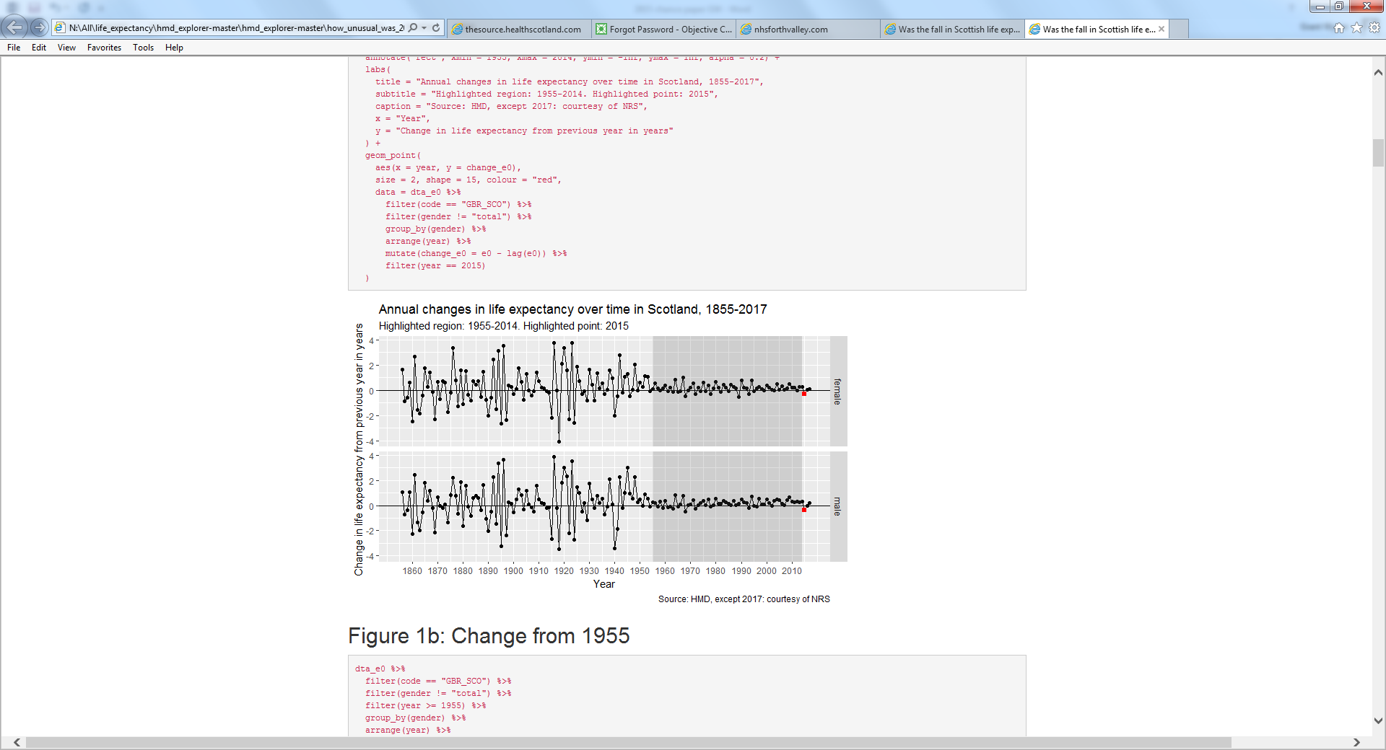

**Table 1: Probability of a fall in life expectancy as extreme as 2015 occurring in a 5-, 10-, 20- and 60-year period by sex, Scotland and England & Wales**

|  |  |  |  |  |  |
| --- | --- | --- | --- | --- | --- |
| **Time period** | **Number of fall outcomes** | **Scotland** | | **England & Wales** | |
|  |  | **Females**  **(AEP = 6.7%)** | **Males**  **(AEP = 1.7%)** | **Females**  **(AEP = 3.3%)** | **Males**  **(AEP = 3.3%)** |
| 5-year risk | None | 70.8% | 91.9% | 84.4% | 84.4% |
|  | 1a | 25.3% | 7.8% | 14.6% | 14.6% |
|  | 2 | 3.6% | 0.3% | 1.0% | 1.0% |
|  | 3 | 0.3% | 0.0% | 0.0% | 0.0% |
|  | 4b | 0.0% | 0.0% | 0.0% | 0.0% |
|  | 5 or more | 0.0% | 0.0% | 0.0% | 0.0% |
|  |  |  |  |  |  |
| 10-year risk | None | 50.2% | 84.5% | 71.2% | 71.2% |
|  | 1a | 35.8% | 14.3% | 24.6% | 24.6% |
|  | 2 | 11.5% | 1.1% | 3.8% | 3.8% |
|  | 3 | 2.2% | 0.0% | 0.4% | 0.4% |
|  | 4b | 0.3% | 0.0% | 0.0% | 0.0% |
|  | 5 or more | 0.0% | 0.0% | 0.0% | 0.0% |
|  |  |  |  |  |  |
| 20-year risk | None | 25.2% | 71.5% | 50.8% | 50.8% |
|  | 1a | 35.9% | 24.2% | 35.0% | 35.0% |
|  | 2 | 24.4% | 3.9% | 11.5% | 11.5% |
|  | 3 | 10.5% | 0.4% | 2.4% | 2.4% |
|  | 4b | 3.2% | 0.0% | 0.3% | 0.3% |
|  | 5 or more | 0.8% | 0.0% | 0.0% | 0.0% |
|  |  |  |  |  |  |
| 60-year risk | None | 1.6% | 36.5% | 13.1% | 13.1% |
|  | 1a | 6.8% | 37.1% | 27.1% | 27.1% |
|  | 2 | 14.4% | 18.5% | 27.5% | 27.5% |
|  | 3 | 19.9% | 6.1% | 18.4% | 18.4% |
|  | 4b | 20.2% | 1.5% | 9.0% | 9.0% |
|  | 5 or more | 37.1% | 0.3% | 5.0% | 5.0% |

a Shaded cells in the table denote the chance of observing at least the number of fall outcomes that were actually observed in the 5-, 10-, 20-, 40-year period preceding 2016.

**Table 2: Autocorrelation model results**

|  |  |  |  |  |  |
| --- | --- | --- | --- | --- | --- |
| **Sex** | **Model Term** | **Estimate** | **Standard Error** | **Statistic** | **P-value** |
| Females | Intercept | 0.26 | 0.041 | 6.401 | p < 0.001 |
|  | Coefficient | -0.47 | 0.115 | -4.077 | p < 0.001 |
|  |  |  |  |  |  |
| Males | Intercept | 0.25 | 0.041 | 6.138 | p < 0.001 |
|  | Coefficient | -0.28 | 0.125 | -2.268 | 0.027 |